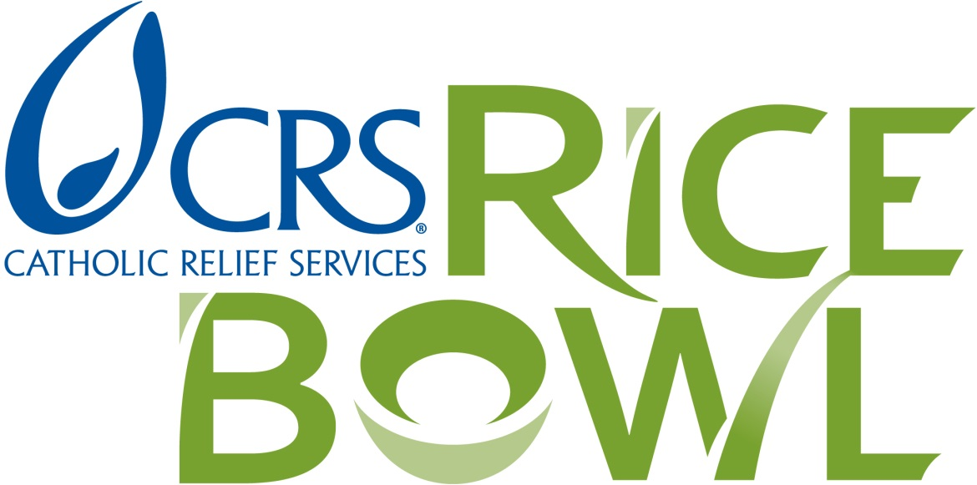

Recipients of the Matthew 25: CRS Rice Bowl Grant

Cathedral Soup Kitchen – Ss. Peter and Paul Cathedral
St. Vincent de Paul Church – Warming Center – Bedford
St. Vincent de Paul Society – St. Agnes – Brown County
St. Benedict Soup Kitchen – Terre Haute
Irvington Churches Advocacy Network – Indianapolis
St. Patrick Soup Kitchen – Terre Haute
Sacred Heart Sack Lunch Program – Terre Haute
God’s Bounty Food Pantry – Nativity – Indianapolis
St. Vincent de Paul Tri-Parish Conference – Corydon
Ss. Francis and Clare Food Pantry – Indianapolis
Catholic Charities – Bethany House – Terre Haute

